**Software Requirement Specification**

***My Store Online Shopping System***

**Overall Description:**

**My Store Online Shopping system** (OSS) application enables vendors to set up online shops, customers to browse through the shops, and a system administrator to approve and reject requests for new shops and maintain lists of shop categories. Also the developer is designing an online shopping site to manage the items in the shop and also help customers to purchase them online without visiting the shop physically. The online shopping system will use the internet as the sole method for selling goods to its consumers.

**Product Perspective:** This product aimed toward a person who don’t want to visit the shop as he might don’t get time for that or might not interested in visiting there and dealing with lot of formalities.

**Product Functions:**

Various functional modules implemented by the system will be :

* ***Registration***

If customer wants to buy the product then he/she must be registered, unregistered user can’t go to the shopping cart.

* ***Login***

Customer logins to the system by entering valid user id and password for the shopping.

* ***Changes to Cart***

Changes to cart means the customer after login or registration can make order or cancel order of the product from the shopping cart.

* ***Payment***

In this system we are dealing with different mode of payment like credit card, debit card, Net banking and Cash on Delivery

* ***Logout***

After ordering or surfing for the product customer has to logout.

* ***Report Generation***

After ordering for the product, the system will sent one copy of the bill to the customer’s Email-address and another one for the system data base.

**Non-Functional Requirements:**

Following Non-Functional Requirements should implement the following on the availability of the internet connectivity.

(i) Secure access to consumer’s confidential data.

(ii) 24X7 availability.

(iii) Better component design to get better performance at peak time.

(iv) Flexible service based architecture will be highly desirable for future extension.

Various other Non-Functional Requirements implemented in this system are:

➢ Security

➢ Reliability

➢ Maintainability

➢ Portability

➢ Extensibility

➢ Reusability

➢ Compatibility

➢ Resource Utilization

**Steps to follow :**

1. The User visit on http://automationpractice.com/index.php site.
2. The portal displays the home page.



1. The user mouse over on any of the product link. The portal displays Add to Cart option.

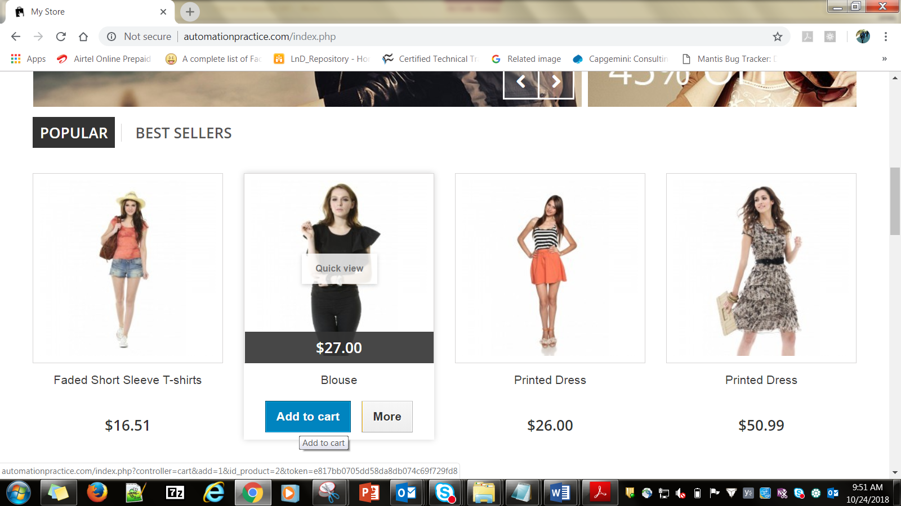

1. The user clicks on the ‘Add to Cart’ button. It displays the following screen for checkout.

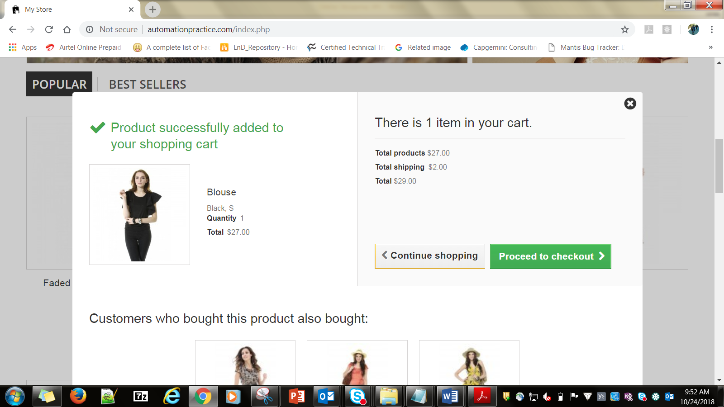

1. The user clicks ‘Proceed to checkout’ and the following screen is displayed for creating a new account

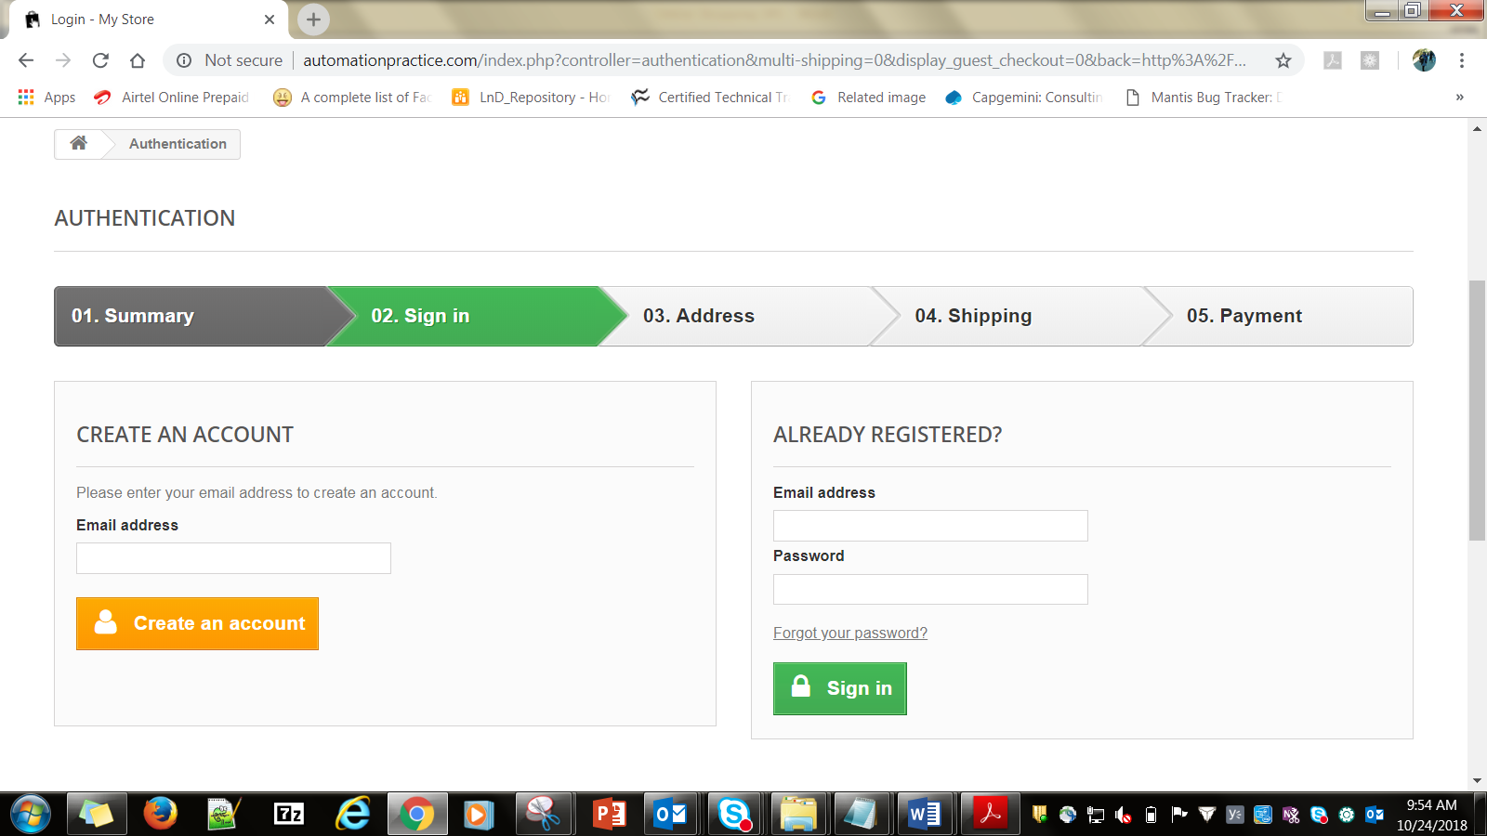

1. The user provides email id and clicks on ‘Create an account’ button and the following screen is displayed for registration of a new customer.

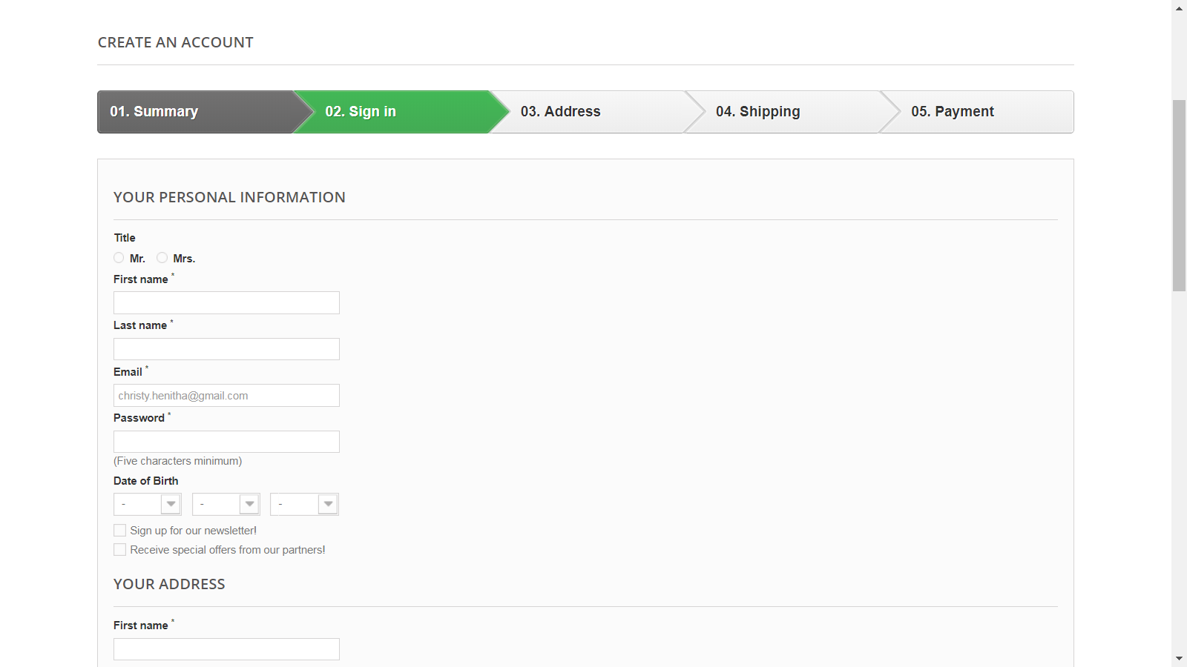

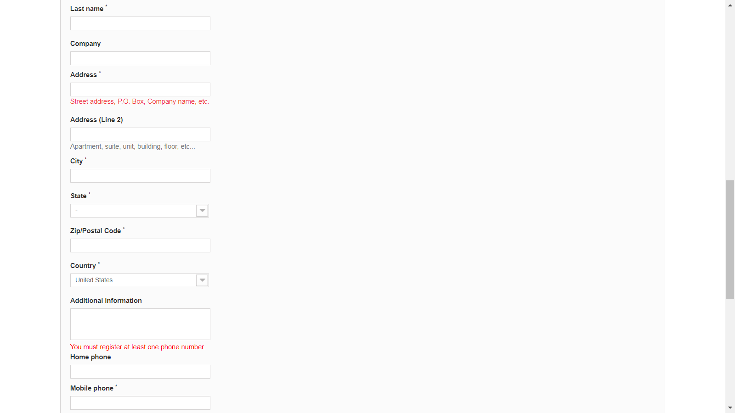

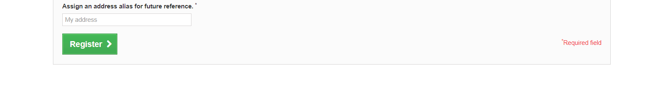

Business Rules for ‘Create an Account’ page.

1. The fields marked as * are mandatory fields.
2. Follow the given rules :

|  |  |
| --- | --- |
| **Fields** | **Description** |
| Title | Select the Option from the following :   * + - * Mr       * Mrs |
| First Name | First name should accept only alphabets.  First name length should be 3 to 30 characters. |
| Last Name | Last name should accept only alphabets.  Last name length should be 3 to 30 characters. |
| |  |  | | --- | --- | | Email |  | | Should accept only valid and existing email. |
| Password | The length should be maximum 6 characters.  It can accept special characters, alphabets, numbers |
| Date of Birth | Month should be between 1-12  Days should be between 1-31 for months Jan, Mar,May, July,Aug,Oct,Dec.  Days should be between 1-30 for months Apr,June,Sep,Nov  Days should be between 1-28 or 1-29 for Fesb month, depending on the leap year |
| Sign up for our newsletter! | It should be a checkbox and not mandatory |
| Receive special offers from our partners! | It should be a checkbox and not mandatory |